Procedure:

1. read STAWA procedure
2. Safety considerations include:

* use of Bunsen burner - use safety flame when not in use
* hot objects - crucible will be very hot from the bunsen burner
  + use metal tongs to move lid when required
  + let crucible and clay triangle cool down sufficiently before cleaning up
* BaCl2 is poisonous - do not let it touch your skin
  + use spatula to move it to the crucible
* wear safety glasses

Further notes at <https://docs.google.com/document/d/11rgNdhQiFNuZy60uDJgigB2TILz0zmf41db6Ro24QUs/edit>

1. in video

Results and Observations:

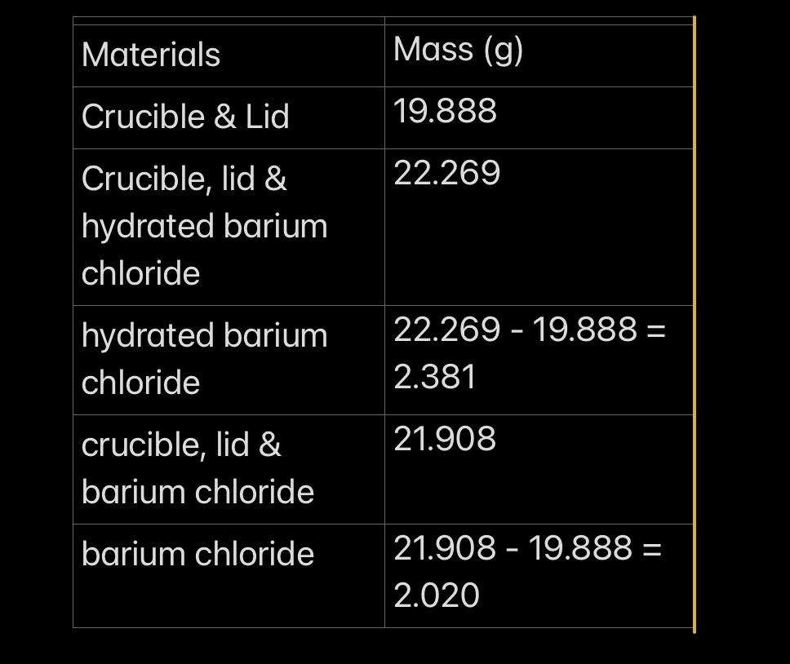

Processing of result and questions

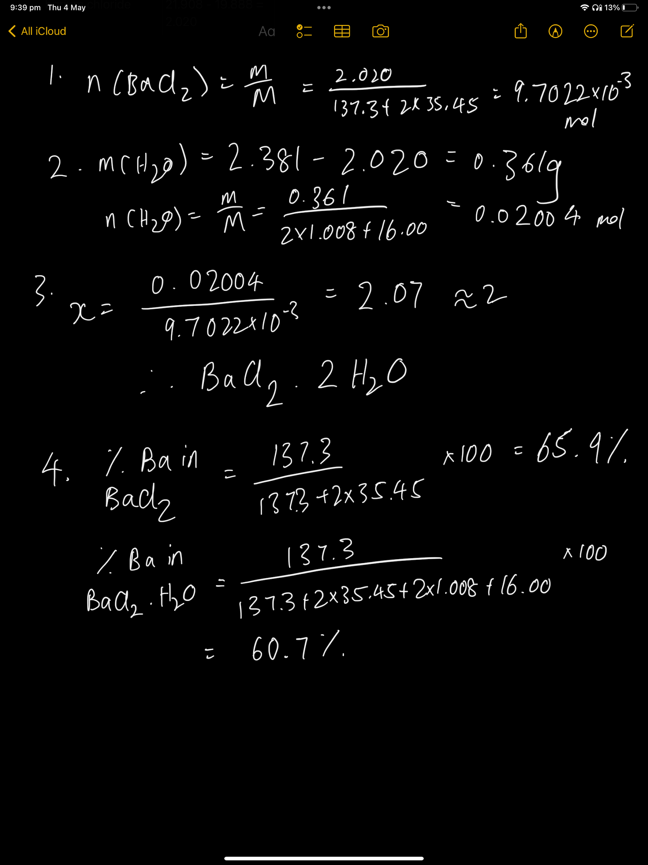

Post-lab questions

